

**Program: ESE 4009**

**INSTRUCTOR:** Prof**.** Mike Aleshams

# Group 6

|  |  |  |
| --- | --- | --- |
| Student Name | Student ID | Signature* |
| Lokesh Chinthakuntla | C0749681 | LC |
| Parthkumar Patel | C0754250 | PP |
| Kunjalben Patel | C0754858 | KP |

*\*By signing above, you attest that you have contributed to this submission and confirm that all work you have contributed to this submission is your own work. Any suspicion of copying or plagiarism in this work will result in an investigation of Academic Misconduct and may result in a “0” on the work, an “F” in the course, or possibly more severe penalties.*

**Project Proposal**

**Project Title: Smart garbage monitoring system**

**Description of the latest similar system:**

This project shows the design and development of smart green environment of garbage monitoring system by measuring the garbage level in real time. The proposed system consisted the ultrasonic sensors which measure the garbage level, an Arduino which controls system operation and send the data to Blynk application which represent the amount of trash in the bin. This work demonstrates a system that allows the waste management to monitor based on the level of the garbage depth inside the dustbin. This process indicates the bins that require attention and use can optimize the garbage collection route and ultimately reduce the fuel consumption. It allows management as well as trash collector to set their pickup schedule accordingly.

**Limitations of the latest similar system:**

* Exiting system used Arduino which has very limited processing speed.
* Blynk is used for transmitting the information which is phone application with GUI.

**Solution 1:**

* We are planning to replace Arduino mkr1000 with an LPC 1768 for real time processing features. In addition, we also need ESP8266 wi-fi module for communication.
* We can also add ThingSpeak cloud service to store real time data so the actual garbage level can be monitored from remote location.

**Block Diagram:**

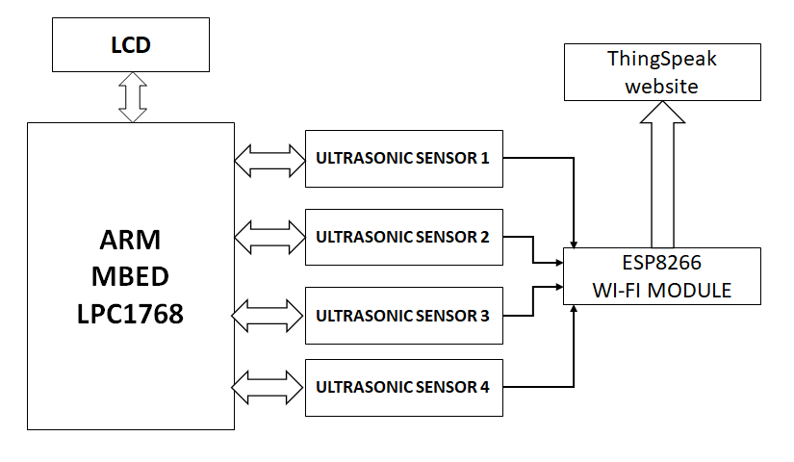

**Hardware and Software Requirement**

ARM mbedLPC1768 micro controller

ESP8266 Wi-fi module

Ultrasonic sensor

LCD display

Logic level converter

Power supply

Jumper wires and breadboard

MCUExpresso IDE

Linux OS

ThingSpeak

Easy EDA

**Features:**

**Use of various peripherals such as touch screens, cameras, microphones and speakers, GPIOs, timers, GPS modules, Bluetooth, WIFI, and ADC/DACs?**

* LPC1768 is used instead of Arduino for real time processing.
* Ultrasonic distance sensor is used for monitoring actual trash.

**Use of I2C, SPI, RS232/RS-485, IrDA infrared, JTAG, USB, Bluetooth, IEEE 802.11 Wifi, IEEE 802.3 Ethernet, CAN and GPS protocols and systems?**

* IEEE 802.11 b/g/n Wi-Fi module is used to transmit the data over internet.
* ThingSpeak for real time data monitoring.
* Data stored in the cloud can be accessible from anywhere.

**Use of preemptive versus cooperative scheduler operation; tick rate and time slicing; critical code; fixed, dynamic and hybrid task priority allocation; application-specific considerations; power management tactics; semaphores, mutexes and queues; debugging strategies; performance estimation?**

* LPC1768 with ARM 32bit Cortex-M3 microcontroller with real-time emulation and embedded trace support.

**References:**

1. Technovation, & Instructables. (2017, August 02). Smart Garbage Monitoring System Using Internet of Things (IOT). Retrieved September 21, 2020, from <https://www.instructables.com/id/Smart-Garbage-Monitoring-System-Using-Internet-of-/>
2. Using the ESP8266 to add Wi Fi to the mbed LPC1768. (2015, December 23). Retrieved September 21, 2020, from <https://os.mbed.com/users/4180_1/notebook/using-the-esp8266-with-the-mbed-lpc1768/>

**Solution 2:**

* LPC1768 can be replaced with Arduino for real time processing.
* IEEE 802.11 b/g/n ESP8266 Wi-Fi module to update the data.
* We can also add ThingSpeak cloud service to store real time data so the actual garbage level can be monitored from remote location.
* IR sensor can be used and placed at different surface of bin to get actual trash present in it.

**Block Diagram:**

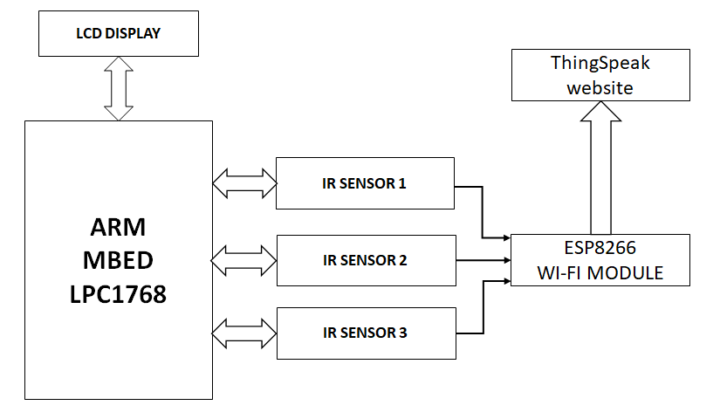

**Hardware and Software Requirement**

ARM mbedLPC1768 micro controller

ESP8266 Wi-fi module

IR sensor

Power supply

Jumper wires and breadboard

MCUExpresso IDE

Linux OS

ThingSpeak

Easy EDA

**Features:**

**Use of various peripherals such as touch screens, cameras, microphones and speakers, GPIOs, timers, GPS modules, Bluetooth, WIFI, and ADC/DACs?**

* LPC1768 is used instead of Arduino for real time processing.
* IR sensor is used for monitoring actual trash.

**Use of I2C, SPI, RS232/RS-485, IrDA infrared, JTAG, USB, Bluetooth, IEEE 802.11 WiFi, IEEE 802.3 Ethernet, CAN and GPS protocols and systems?**

* IEEE 802.11 b/g/n Wi-Fi module is used to transmit the data over internet.
* ThingSpeak for real time data monitoring.
* Data stored in the cloud can be accessible from anywhere.

**Use of preemptive versus cooperative scheduler operation; tick rate and time slicing; critical code; fixed, dynamic and hybrid task priority allocation; application-specific considerations; power management tactics; semaphores, mutexes and queues; debugging strategies; performance estimation?**

* LPC1768 with ARM 32bit Cortex-M3 microcontroller with real-time emulation and embedded trace support

**References:**

1. Technovation, & Instructables. (2017, August 02). Smart Garbage Monitoring System Using Internet of Things (IOT). Retrieved September 21, 2020, from <https://www.instructables.com/id/Smart-Garbage-Monitoring-System-Using-Internet-of-/>
2. Using the ESP8266 to add Wi Fi to the mbed LPC1768. (2015, December 23). Retrieved September 21, 2020, from <https://os.mbed.com/users/4180_1/notebook/using-the-esp8266-with-the-mbed-lpc1768/>

**Final Solution (after presentation):**

* **Block Diagram**

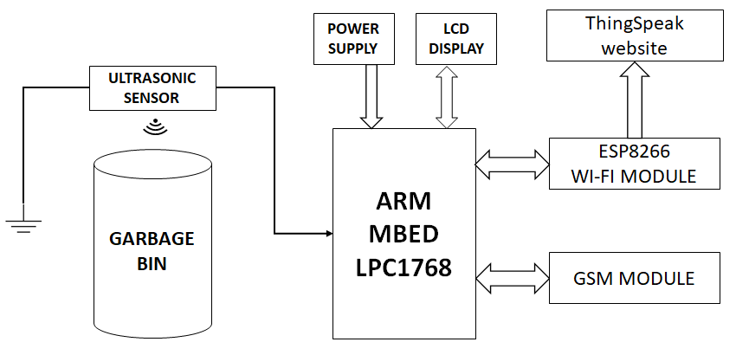

**Flow chart:**

**WORKSTATION**

**MESSAGE**

**GARBAGE BIN**

**THINGSPEAK**

**GSM**

**LCD DISPLAY**

**WI-FI MODULE**

**THRESOLD LEVEL REACHED?**

**ULTRASONIC SENSOR**

**NO**

**YES**

* **Features**
* **Use of various peripherals such as touch screens, cameras, microphones and speakers, GPIOs, timers, GPS modules, Bluetooth, Wifi, and ADC/DACs?**
* LPC1768 is used instead of Arduino for real time processing.
* Ultrasonic sensor is used for monitoring actual trash.
* **Use of I2C, SPI, RS232/RS-485, IrDA infrared, JTAG, USB, Bluetooth, IEEE 802.11 WIFI, IEEE 802.3 Ethernet, CAN and GPS protocols and systems?**
* IEEE 802.11 b/g/n Wi-Fi module is used to transmit the data over internet.
* ThingSpeak for real time data monitoring.
* Data stored in the cloud can be accessible from anywhere.
* LPC 1768 supports I2C and SPI interface to connect with LCD.
* ESP8266 WIFI Module can be interface to LPC1768 using IEEE 802.11b/g/n protocol.
* Interfacing LPC 1768 to ultrasonic sensor using GPIO.
  + We are using SIM 800 GSM module to sending message from LPC1768 to mobile.
* UART can be used to connect LPC 1768 with GSM Module.
* **Use of preemptive versus cooperative scheduler operation; tick rate and time slicing; critical code; fixed, dynamic and hybrid task priority allocation; application-specific considerations; power management tactics; semaphores, mutexes and queues; debugging strategies; performance estimation?**
* LPC1768 with ARM 32bit Cortex-M3 microcontroller with real-time emulation and embedded trace support.
* We will use Power Management tactics to minimize power consumption when a device is inactive.
* **Hardware and Software Requirement**

ARM mbedLPC1768 micro controller

ESP8266 Wi-fi module

GSM module

LCD display

Ultrasonic sensor

Power supply

Jumper wires and breadboard

Easy EDA

MCUExpresso IDE

Linux OS

ThingSpeak

Hardware embedded tools

1. Soldering iron: Soldering iron is very essential hardware tool as it used to connect two components together or to fix the components on PCB. We can use soldering iron to develop the circuit on circuit board as per the requirement after testing on bread board.
2. Desoldering Gun: Desoldering gun is used to desolder the components from each other or from PCB in case of any wrong connection or to replace the failure components.
3. Digital Multimeter: Digital multimeter is very important tool while working with projects related to electronics. Digital multimeter can be used for testing the components by checking its resistance, continuity for their reliable working. It can be used to measure the voltage, current and to find fault in the circuit.
4. Oscilloscope: Oscilloscope is used to monitor or to set the input and output signal in the circuit.
5. Cutter and stripper: Cutter are hardware tool generally used to cut the wire while stripper is used to strip off the insulation from wire without damaging the conductor.
6. Laptop: Laptop is the most important tools required for embedded system development. With help of laptop we can write the code, simulate the circuit, for research and many more.
7. Ultrasonic sensor: We will use HC-SR04 Ultrasonic sensor which indicates the level of garbage filled in dustbin and we will plant Ultrasonic sensor at top of the dustbin to show us the actual level of garbage present in it.
8. Lithium-Ion battery: We will use Lithium-Ion battery to give the supply voltage to the LPC1768, IR sensors and LCD.

Software Tools:

1. MCUXPRESSO IDE: This is one of the main software tools of our project. as we will use MCUExpresso to write, debug and compile code. For LPC1768.
2. WIFI: We are going to use 802.11b/g/n protocol. Wi-Fi module helps us to send the details of the dustbin over cloud.
3. Ubuntu: Ubuntu is an open-source Debian based Linux distribution. We are using Ubuntu as an operating system.
4. Easy EDA: Easy Eda is a software in which we can make an easily schematic capture, PCB and circuit stimulation.
5. GNU Compiler: We are using GNU compiler to compile the program written in C and C++.

* **Milestones (Deliverables and Time Schedule)**

|  |  |  |  |
| --- | --- | --- | --- |
| **TASK NAME** | **START DATE** | **END DATE** | **PERSON-IN-CHARGE** |
| Project Proposal | Sep-21-2020 | Sep-25-2020 |  |
| Finalizing Hardware Requirements and ordering | Sep-25-2020 | Oct-09-2020 | Lokesh |
| Testing Each Hardware parts | Oct-09-2020 | Oct-23-2020 | Parth Patel |
| Designing circuit in software | Oct-13-2020 | Oct-23-2020 | Kunjal Patel |
| Interfacing Ultrasonic-Sensors with LPC1768 | Oct-26-2020 | Oct-30-2020 | Parth Patel |
| Interfacing LCD with LPC1768 | Nov-02-2020 | Nov-09-2020 | Kunjal Patel |
| Setting GSM Module with LPC1768 | Nov-10-2020 | Nov-13-2020 | Lokesh |
| Interfacing WI-FI module with LPC1768 | Nov-16-2020 | Nov-20-2020 | Parth Patel |
| Interfacing THINGSPEAK with LPC1768 | Nov-23-2020 | Nov-27-2020 | Lokesh |
| PCB Designing | Nov-30-2020 | Dec-11-2020 | Kunjal Patel |
| Final report | Dec-06-2020 | Dec-15-2020 |  |
| Final Presentation | Dec-13-2020 | Dec-18-2020 |  |

**COST ESTIMATION**

|  |  |  |
| --- | --- | --- |
| item | Cost ($) | Link |
| LPC1768 | $ 75 | <https://www.digikey.ca/en/products/detail/nxp-usa-inc/OM11043,598/2138502> |
| SIM 800 GSM module | $ 22 | <https://www.amazon.ca/Dolity-SIM800L-Module-Antenna-Arduino/dp/B07B8SMYW5> |
| Wifi 802.1 module USBtype | $ 12 | <https://www.digikey.ca/en/products/detail/schtoeta-engineering-limited/ESP8266-DEVKITC-02D-F/9649768?utm_adgroup=RF%20Evaluation%20and%20Development%20Kits%2C%20Boards&utm_source=google&utm_medium=cpc&utm_campaign=Shopping_Product_RF%2FIF%20and%20RFID&utm_term=&productid=9649768&gclid=CjwKCAjwiOv7BRBREiwAXHbv3FeJlQyEwiF1OLbb6GnrW49ZJKO-sNbZNdJUO7g6hFP8CDKvsm_BbBoCrBwQAvD_BwE> |
| li-ion battery | $ 5 | <https://www.digikey.com/product-detail/en/sparkfun-electronics/PRT-13853/1568-1491-ND/6605197> |
| Bin | $ 15 | Walmart |
| Ultrasonic sensors | $ 4 | <https://www.sparkfun.com/products/15569> |
| LCD display | $ 30 | <https://www.digikey.ca/en/products/detail/sparkfun-electronics/LCD-14073/9559123> |
| PCB designing | $ 50- 80 | Approx. |
| Jumper wire kit | $ 10 | <https://www.digikey.ca/en/products/detail/global-specialties/WK-2/5231341?s=N4IgjCBcoLQdIDGUAuAnArgUwDQgPZQDa4A7AGwCcIAugL514BMxIA6gNIwv1A> |
| Breadboard | $ 13 | <https://www.digikey.ca/en/products/detail/global-specialties/GS-830/5231309> |
| Resistor kit | $ 15 | <https://www.amazon.com/Sparkfun-500-4W-Resistor-Kit/dp/B008MH97I4> |
| DMM & solder iron kit | $ 30 | <https://www.amazon.ca/Multimeter-Adjustable-Temperature-Controlled-Screwdriver/dp/B07G9MTT72/ref=sr_1_5?crid=RUK4VBLK7FBZ&dchild=1&keywords=digital+multimeter+kit&qid=1601608873&sprefix=digital+multim%2Caps%2C253&sr=8-5> |
| Total | $ 310 + Tax |  |

**Standards for Communication & Coding:**

**I2C Protocol:**

The Inter-Integrated Circuit (I2C) Protocol is a protocol intended to allow multiple slave digital integrated circuits to communicate with one or more master chips.

We will use I2C protocol for the interfacing of LPC 1768 with LCD.

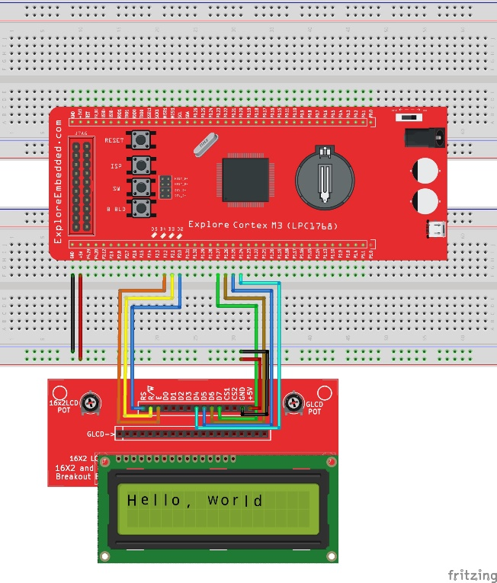

* The I2C requires only two wires to transmit information among devices while SPI requires three or four.
* I2C supports multiple devices on the same bus without additional select signal lines through in-communication device addressing.
* I2C protocol is cheaper to implement than the SPI communication protocol.
* I2C is Less susceptible to noise than SPI.

**UART Protocol:**

UART (Universal Asynchronous Receiver/Transmitter) is a serial communication protocol in which data is transferred serially bit by bit at a time between two electronics devices.

It can operate between devices in 3 ways:

Simplex = data transmission in one direction

Half duplex = data transmission in either direction but not simultaneously

Full duplex = data transmission in both directions simultaneously

We are using UART Protocol to interface LPC1768 to GSM Module, ESP8266 and Ultrasonic sensor.

* UART is easy to operate and have many resources to learn about UART.
* No clock is needed in UART as it is asynchronous serial protocol.
* UART allows parity bit for error checking.
* UART is bidirectional protocol so transmitting and receiving data at the same is possible.

**IEEE 802.11b/g/n**

802.11n is a specification for wireless LAN communications. 802.11n was the next of IEEE 802.11 standards after 802.11a, 802.11b, and 802.11g.

We are using IEEE 802.11n protocol to interface LPC 1768 with wifi module ESP 8266.

* This protocol has improvement of significant bandwidth compared to other standards.
* 802.11n can support 802.11a, b and g standards for connecting the legacy clients too.
* 802.11n is less prone to interference
* 802.11n uses the newest security

**MQQT protocol**

MQQT (Message Queuing Telemetry Transport) is a Machine-to-Machine connectivity protocol. It allows data to be **published** and **subscribed** to by clients through one central server on topic channels. The MQTT protocol allows a supervisory control and data acquisition system to access industrial IoT data. Advantages of MQQT are as follows

* More efficient information distribution
* Reduce network bandwidth consumption dramatically
* Maximize available bandwidth
* Well suited for remote sensing and control
* Very secure with permission-based security
* Saves development time

**MISRA C**

MISRA is a coding standard for C and C++ developed by the Motor Industry Software Reliability Association. We are using MISRA standards to ensure our code is Safe, Secure, Reliable and Portable. MISRA is made up of manufacturers, component suppliers, and engineering consultancies. MISRA C has 127 rules among them 93 are required and 34 are advisory.

MISRA C Coding standard rules:

* All code shall conform to ISO 9899 standard C, with no extensions permitted. (Required)
* Only those characters and escape sequences which are defined in the ISO C standard shall be used. (Required)
* Values of character types shall be restricted to a defined and documented subset of ISO 10646-1.(Required)
* Comments shall not be nested. (Required)
* Sections of code should not be ‘commented out’.(Advisory)
* The type char shall always be declared as unsigned character or signed char. (Required)

**Environmental, Legal and Ethical Ramification:**

**Environmental ramification:**

One of the main concerns with our environment has been solid waste management which impacts the health and environment of our society. The detection, monitoring and management of wastes is one of the primary problems of the present era. The traditional way of manually monitoring the wastes in waste bins is a cumbersome process and utilizes more human effort, time and cost which can easily be avoided with our present technologies. Our Garbage monitoring system is an innovative way that will help to keep the cities clean, healthy and has no side effects on environment.

**Legal ramification:**

We studied many research papers related to waste management. Most of these papers focus only on functionality of garbage monitoring with lack of IOT things and interfaced with Arduino board and PIC microcontroller to update the filled-up levels of garbage through mobile application or through LEDs. This proposed draft comprises hardware, software and communication integrated into a solution that aims to optimize the management of the waste produced in the cities through an approach that generates saving of the public money, contribute with environment and also encourages citizenship. we added latest LPC1768 with ARM 32bit Cortex-M3 microcontroller and Ultrasonic sensor along with actual level of garbage showing on ThingSpeak website through Wi-Fi communication as well as on LCD display.

We can check status of garbage bin on regular bin so in case of any failure of system or miss lead data we can identified at early stage and action could be taken before surrounding area messed through overflow waste from bin.

By setting up project on ThingSpeak website only user has a access to check the status by log in into the project and privacy kept confidential.

**Ethical ramification:**

Proposed draft presented an efficient IOT based real time waste management model for improving the living environment in cities, focused on a citizen perspective. System uses sensor and communication technologies where waste data is collected from smart bin, in real time and transmitted to an online platform along with alert message to user through GSM module which can improve the way people deal with their garbage and optimize economic and material resources. By implementing this system and its consequences brings positive changes to the environment as well as save times and has no negative impact on human being which found ethically right.

**Bill of materials:**

A bill of materials (BOM) is an extensive list of parts, items, congregations, and different materials needed to make a project, just as directions required for gathering and using the necessary materials. The bill of material of our proposal is as below:

|  |  |  |  |  |
| --- | --- | --- | --- | --- |
| Part Number | Part Name | Quantity | Manufacture | Description |
| 568-4916-ND | MBED LPC176X DEV EVAL BRD | 1 | NXP USA Inc | Cortex®-M3 microcontroller for embedded applications featuring a high level of integration and low power consumption |
| 2221-M004-ND | GSM MODULE SIM800L WITH MIC | 1 | M5Stack Technology Co., Ltd. | SIM800A support Quad-band 850/900/1800/1900 MHz, it can transmit Voice, SMS, and data information with low power consumption. |
| 1965-1001-ND | ESP8266-DEVKITC-02D-EVAL BOARD | 1 | Espressif Systems | self-contained SOC with integrated TCP/IP protocol stack that can give any microcontroller access to your WIFI network. |
| 1568-1904-ND | LCD MODULE 32 DIG 16 X 2 | 1 | SparkFun Electronics | 16x2, RGB on Black Display. Three communication options: Serial, I2C and SPI. Incoming buffer stores up to 80 characters |
| 1568-1491-ND | BATTERY LITHIUM 3.7V 110MAH | 1 | SparkFun Electronics | This battery is used to supply the power to the system |
| 490-7706-ND | ULTRASONIC SENSOR | 1 | Murata Electronics | the distance of a target object by emitting ultrasonic sound waves and converts the reflected sound into an electrical signal. |
| BKWK-2-ND | JUMPER KIT VARIOUS 22AWG 140PCS | 1 | Global Specialties | Fastens across splices to provide a secure ground between sections of ladder |
| BKGS-830-ND | BREADBRD TERM STRIP 6.50X2.13" | 2 | Global Specialties | hold electronic components (transistors, resistors, chips, etc.) that are wired together. Used to develop prototypes of electronic circuits |
| KIT-RMCF0402FT-05-ND | RES KIT 10K-97.6K 1/16W 2880PCS | 1 | Stackpole Electronics Inc | Thick Film Resistor Kit 10k ~ 97.6k Ohm ±1% 1/16W Surface Mount 2880 Pieces (96 Values - 30 Each) |
| B07VNBD4B9 | Soldering Iron Kit Station and DMM | 1 | ANCRAFT | Soldering Iron is used to solder the components and digital multimeter is used to measure voltage, resistance and so on. |

**Engineering Drawing:** An engineering drawing is a subcategory of technical drawings. Engineering drawings use standardized language and symbols.

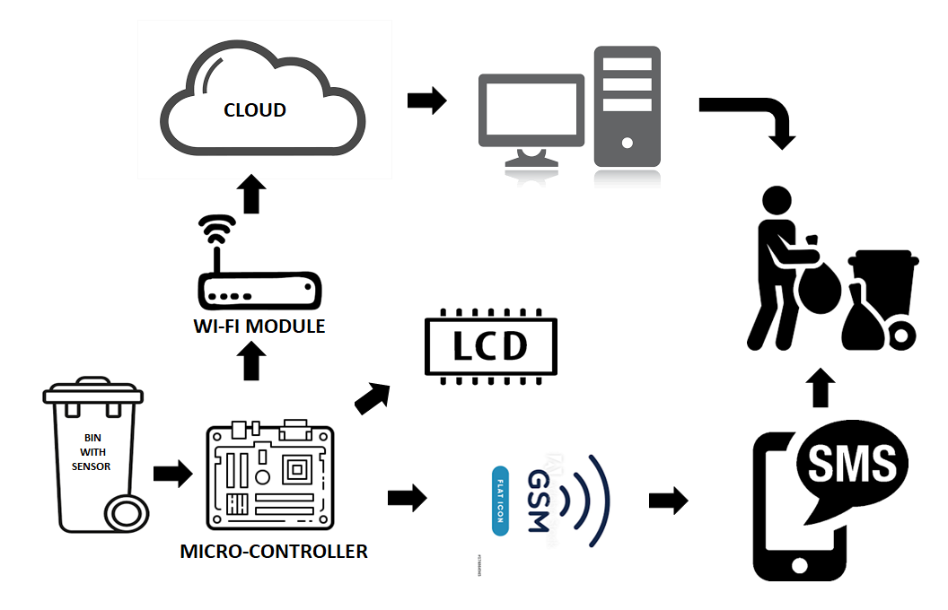

Embedded Software Development tools:

1) A target System

* The target embedded system might offer a dynamic loader, a link loader and a debug agent.
* After the completion of programming work, the task is moved from host machine to target system.
* For our project, we are going to use LPC 1768 as a target system. We will use 32-bit ARM cortex-M3 processor running at 96Mhz with 512KB flash and 32KB RAM.
* LPC 1768 sends the commands to the LCD, ThingSpeak, and to GSM system through which we can know the status of our garbage bin.

2) Simulator

* Simulator is used to monitor the detailed information of a source code part with labels and symbolic arguments as the execution goes on for each single step.
* We will use Easy EDA as a simulator.
* Easy EDA helps us to draw schematics quickly using the available libraries. Using Spice simulation, we can verify analog, digital and mixed signal circuits.
* We can also make PCB Layout using Easy EDA.

3) Integrated Development Environment

* An Integrated Development Environment is a software application that provides comprehensive facilities for software development.
* An IDE generally consists of source code editor, build automation tools and a debugger.
* We are using MCUXpresso as a IDE.
* MCUXpresso IDE is fully featured software development environment for NXP’s arm based MCUs.
* It comprises if GNU tool integration which we will use for compiling and debugging the code.
* It also provides libraries and other tools necessary for developers.
* **References:**

1. Technovation, & Instructables. (2017, August 02). Smart Garbage Monitoring System Using Internet of Things (IOT). Retrieved September 21, 2020, from <https://www.instructables.com/id/Smart-Garbage-Monitoring-System-Using-Internet-of-/>
2. Using the ESP8266 to add Wi Fi to the mbed LPC1768. (2015, December 23). Retrieved September 21, 2020, from <https://os.mbed.com/users/4180_1/notebook/using-the-esp8266-with-the-mbed-lpc1768/>
3. Wire Cutters, Wire Strippers, Pliers & Crimpers. (n.d.). Retrieved September 25, 2020, from <https://www.jameco.com/Jameco/workshop/ProductNews/wire-cutters-strippers-pliers-wire-tools.html>
4. 4. V., Veerraju, 17, M., & Madhavi. (2017, June 17). What are the Main Embedded System Development Tools? Retrieved September 25, 2020, from

[https://microcontrollerslab.com/main-embedded-system-development-tools/](https://microcontrollerslab.com/main-embedded-system-development-tools/   )

5. Burris, M. (2020, September 22). Selecting Between I2C and SPI for Your Project. Retrieved October 02, 2020, from <https://www.lifewire.com/selecting-between-i2c-and-spi-819003>

6. MISRA C rules reference. (n.d.). Retrieved October 02, 2020, from <https://studfile.net/preview/1679059/page:5/>

7. Yida 1 year ago, Yida, Says:, J., & Says:, R. (2020, February 03). UART vs I2C vs SPI – Communication Protocols and Uses. Retrieved October 02, 2020, from <https://www.seeedstudio.com/blog/2019/09/25/uart-vs-i2c-vs-spi-communication-protocols-and-uses/>

8. What is MQTT? (n.d.). Retrieved October 02, 2020, from <https://inductiveautomation.com/resources/article/what-is-mqtt>

9. Velling, A. (2020, August 14). Engineering Drawing Views & Basics Explained. Retrieved October 06, 2020, from <https://fractory.com/engineering-drawing-basics/>

10. What is a Bill of Materials (BOM) and How Do You Create One? (2020, August 31). Retrieved October 06, 2020, from <https://www.arenasolutions.com/resources/category/bom-management/creating-a-bill-of-materials/>

11.Interfacing HC-SR04 Ultrasonic Distance Sensor with LPC1768. (2018, April 12). Retrieved October 09, 2020, from <http://www.ocfreaks.com/interfacing-hc-sr04-ultrasonic-distance-sensor-lpc1768/>

12. MCUXpresso Integrated Development Environment (IDE). (n.d.). Retrieved October 09, 2020, from <https://www.nxp.com/design/software/development-software/mcuxpresso-software-and-tools-/mcuxpresso-integrated-development-environment-ide:MCUXpresso-IDE>

**Instructor’s Remarks:**